**Agenda Brief:**

MX.0 Southeast Event

<https://www.mx0southeast.com/>

**Overview**

Replace this current agenda page: <https://www.mx0southeast.com/agenda>

With one that is this format: [Schedule - GatherFlow - Webflow HTML website template](https://gatherflow-template.webflow.io/schedule)

The page header should remain the same as what is shown here: <https://www.mx0southeast.com/agenda>

Page layout to look like this:

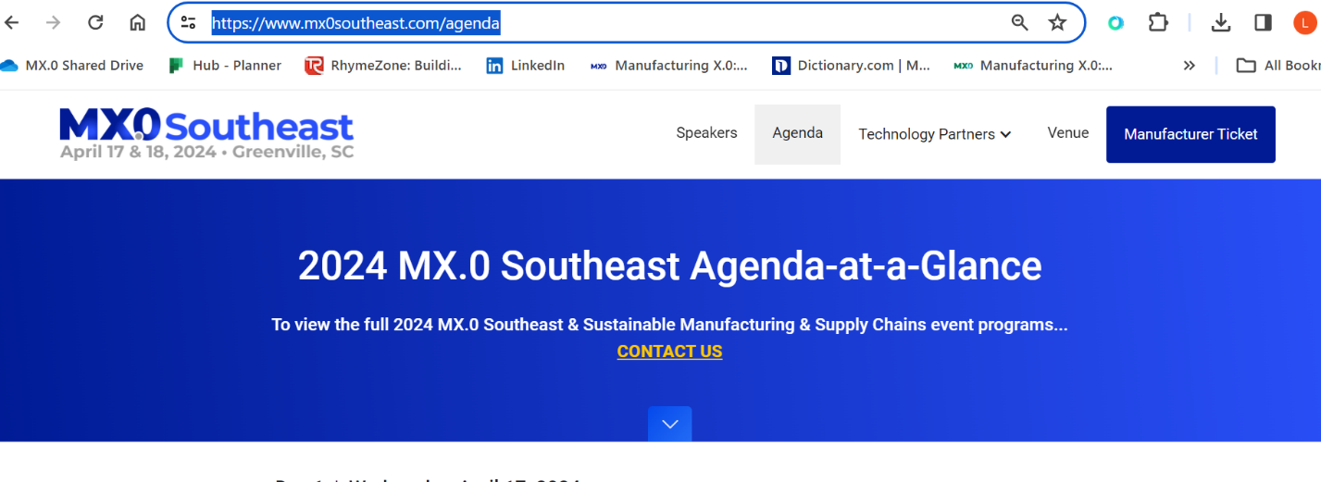

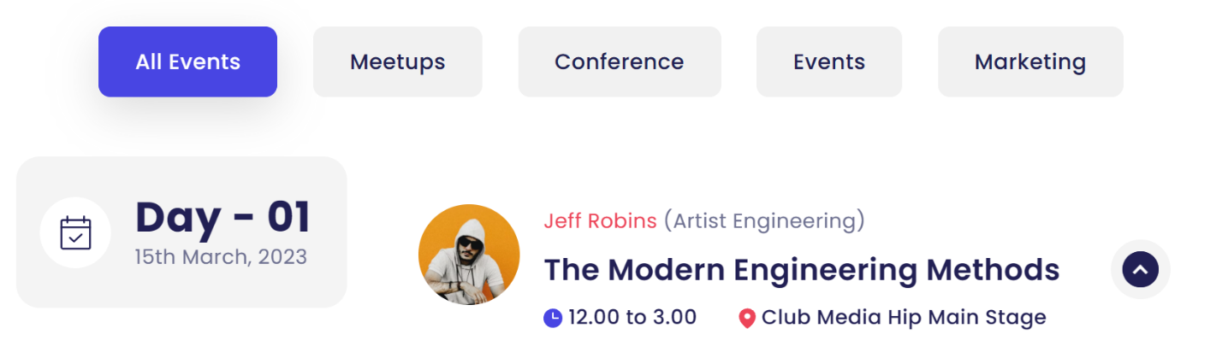

**Tabs/ Headers to include:**

|  |  |  |  |
| --- | --- | --- | --- |
| **All Events** | **Tours & Socials** | **MX.0 Southeast Agendas** | **Sustainable Manufacturing & Supply Chains** |

Please copy all content from the Tours & Socials, MX.0 Southeast and Sustainable Manufacturing & Supply Chains columns into the All Events column.

**Day 1 Schedule to include:**

**April 17, 2024**

|  |  |  |  |
| --- | --- | --- | --- |
| **All Events** | **Tours & Socials** | **MX.0 Southeast Agendas** | **Sustainable Manufacturing & Supply Chains** |
|  | *Speaker photo:***BMW logo - included**  *Speaker (where Jeff Robins is listed in the example above)*: **BMW Leader**  *Time:* **9.00 AM – 4.00 PM**  *Location:* **BMW, Greer, SC**  *Session Description:* **Join BMW’s manufacturing experts as they guide you through BMW’s major and newest body shop tour and answer your questions on the technologies they’ve implemented.** |  |  |
|  | *Speaker photo:* **CMI logo - included**  *Speakers:*  **Kelvin Byrd, Associate Dean of Industrial Manufacturing, Greenville Technical College**  **Raymond L. James, Assistant Dean, Advanced Manufacturing and Transportation Technology, Greenville Technical College**  *Time:* **9:00 AM – 2:00 PM**  *Location:***Greenville Technical College**  *Session Description:* **Visit Greenville Technical College's Center of Manufacturing Innovation, showcasing the latest advanced manufacturing education and training available.** |  |  |
|  | *Speaker photo:***Gemba Systems – logo included**  *Speaker (where Jeff Robins is listed in the example above)*: **Drinks Social hosted by Gemba Systems**  *Time:* **7:00 PM – 9:00 PM**  *Location:* **SIP Whiskey & Wine Bar, Greenville, SC** |  |  |

**Day 2 Schedule to include:**

**April 18, 2024**

|  |  |  |  |
| --- | --- | --- | --- |
| **All Events** | **Tours & Socials** | **MX.0 Southeast Agendas** | **Sustainable Manufacturing & Supply Chains** |
|  | *Speaker photo:***Squint– logo included**  *Speaker (where Jeff Robins is listed in the example above)*: **End of Conference Drinks hosted by Squint**  *Time:* **5:00 PM – 6:30 PM**  *Location:* **The Terrace, Embassy Suites by Hilton Greenville Golf Resort & Conference Center** | *Please take content from Excel spreadsheet* | *Please take content from Excel spreadsheet* |

**Brand Colors:**

**MX.0 Southeast**

Blue 1 – #021B94

Blue 2 – #2A50F9

Grey – #6F6F6E

Gold - #ffd900

**Sustainable Manufacturing & Supply Chains**

Green 1: #004c4e

Green 2: #00be97

Blue 1: #00b5d1

Blue 2: #005077